GIT CHALLENGES
1)Create a merge conflict intentionally (two users editing the same line).
Repository Initialization:
• git init → Creates a new Git repository
• cd challenges → Moves into the project directory
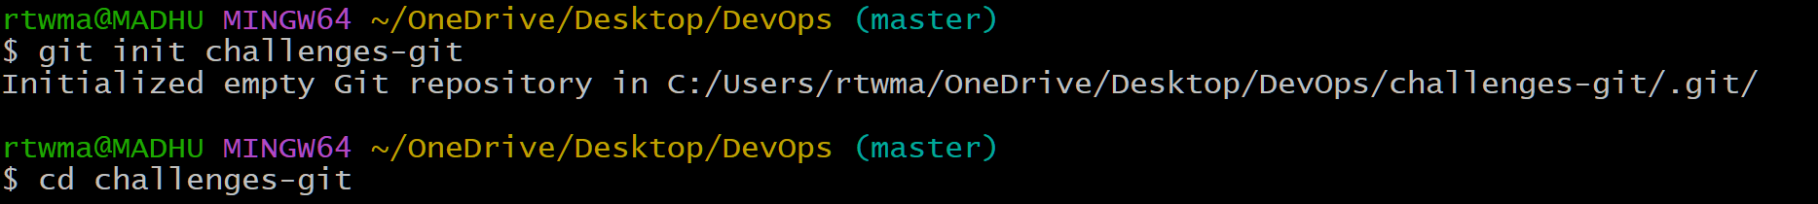
Create Initial File
• touch → Creates file
• vi → Add content in file
• cat → Show content in file
• git add → Stages file for commit
• git commit → Saves snapshot
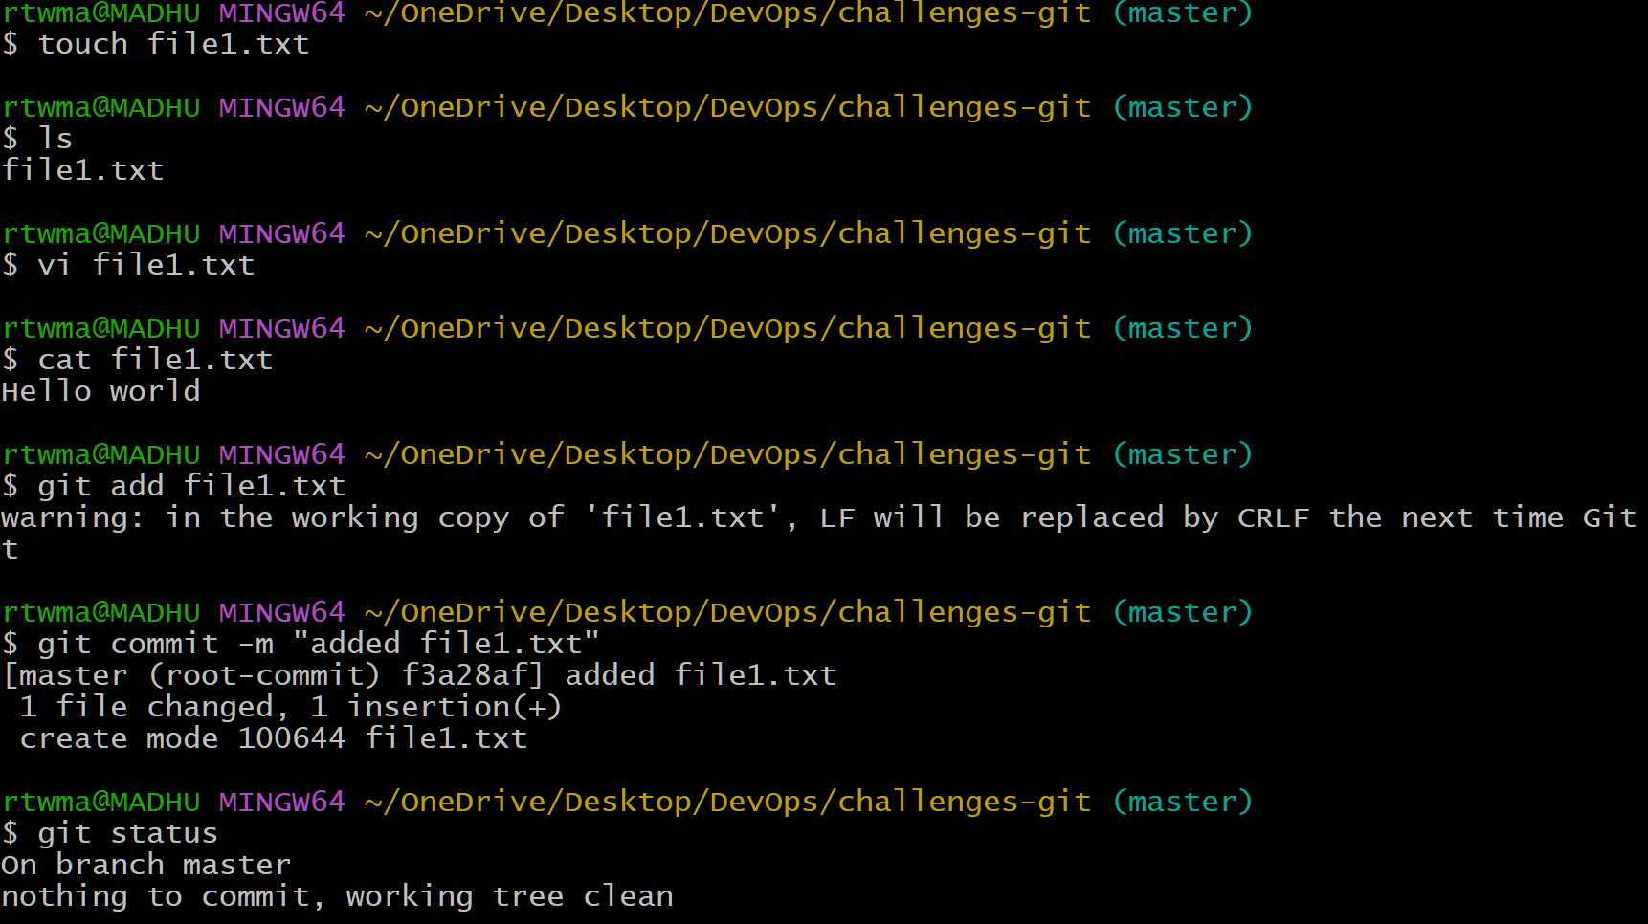

Create First Branch (branch1)
• git branch branch1 → Creates a new branch as branch1
• using echo file content is changed
• Commit saves branch1 version
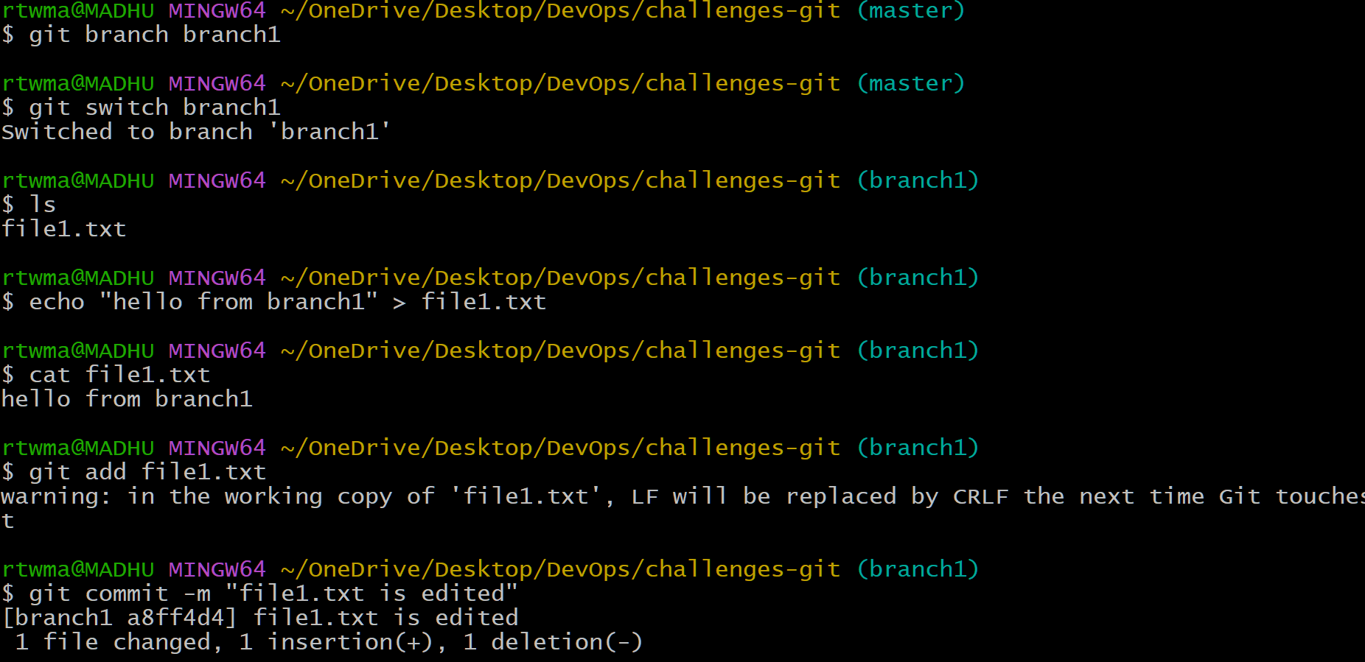
Create Second branch (branch2)
• git branch branch2 → Creates a new branch as branch2
• using echo file content is changed
• Commit saves branch2 version
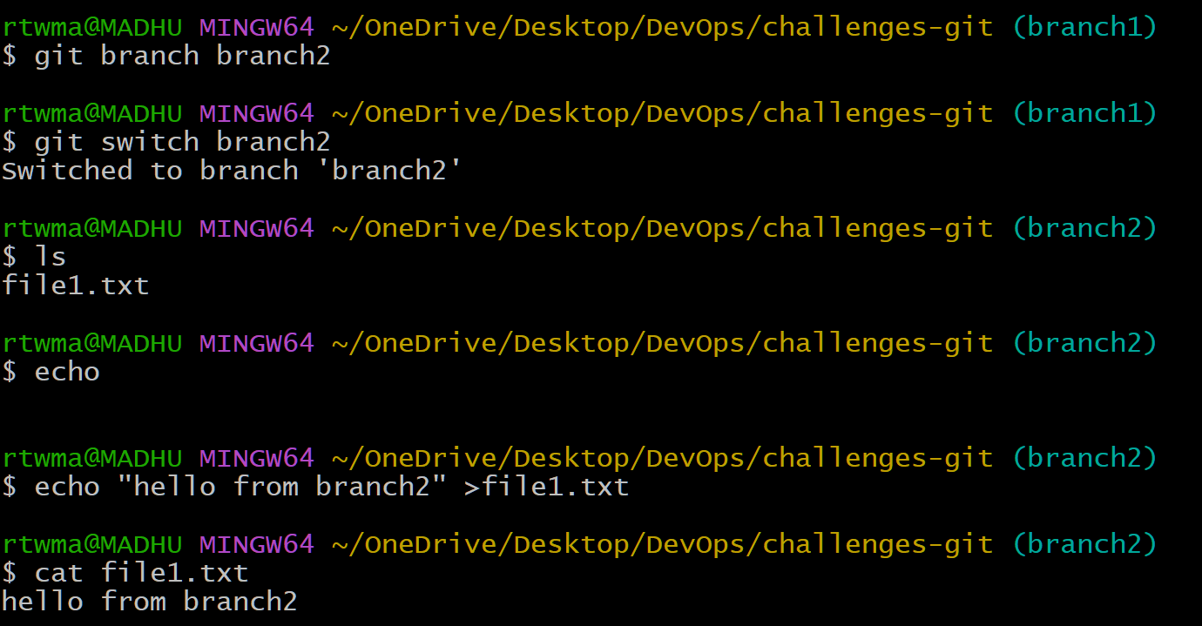
git log --oneline
We are viewing commit history in a short format. 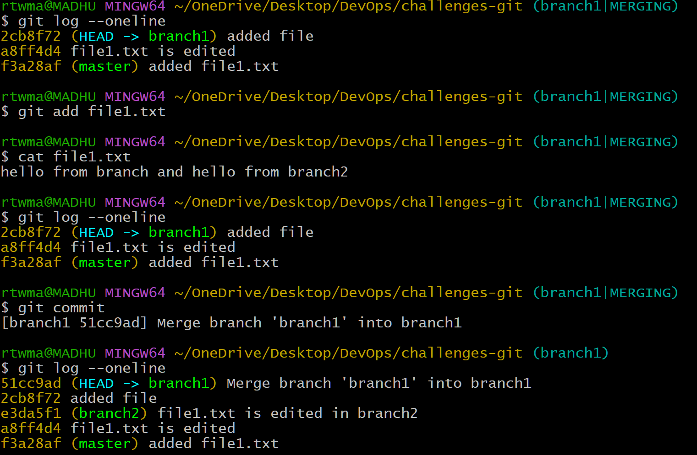
Resolve the conflict and push the changes.
• git remote → Displays or manages the remote repository connections linked to your local Git repository.
• git push → Uploads your local commits to a remote repository such as GitHub.
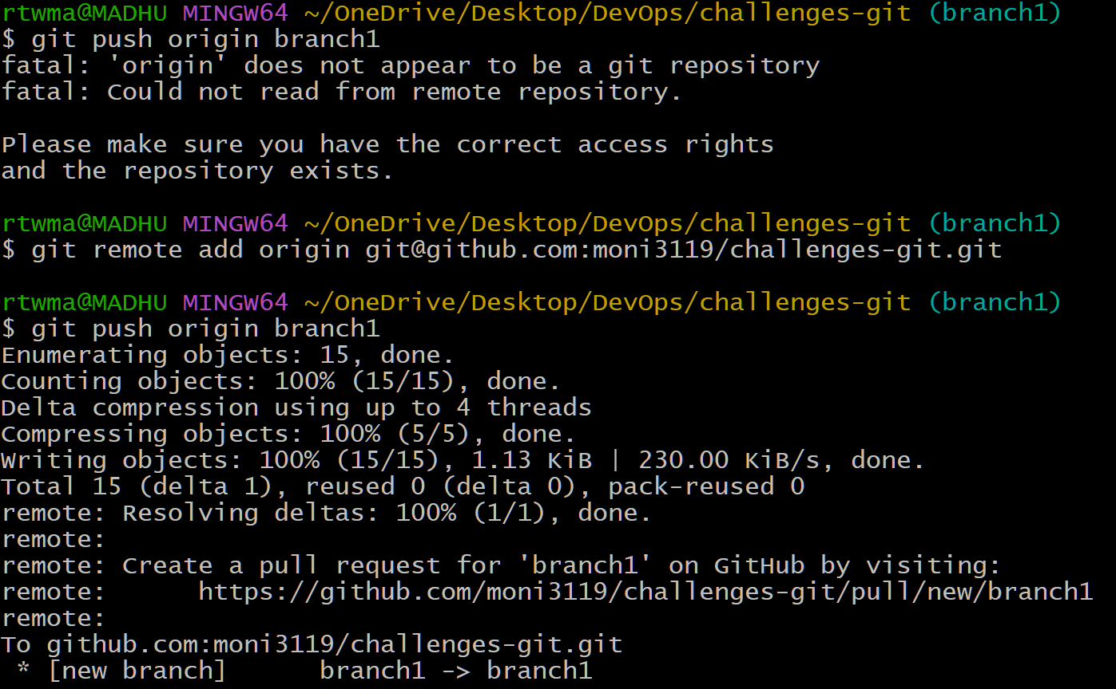
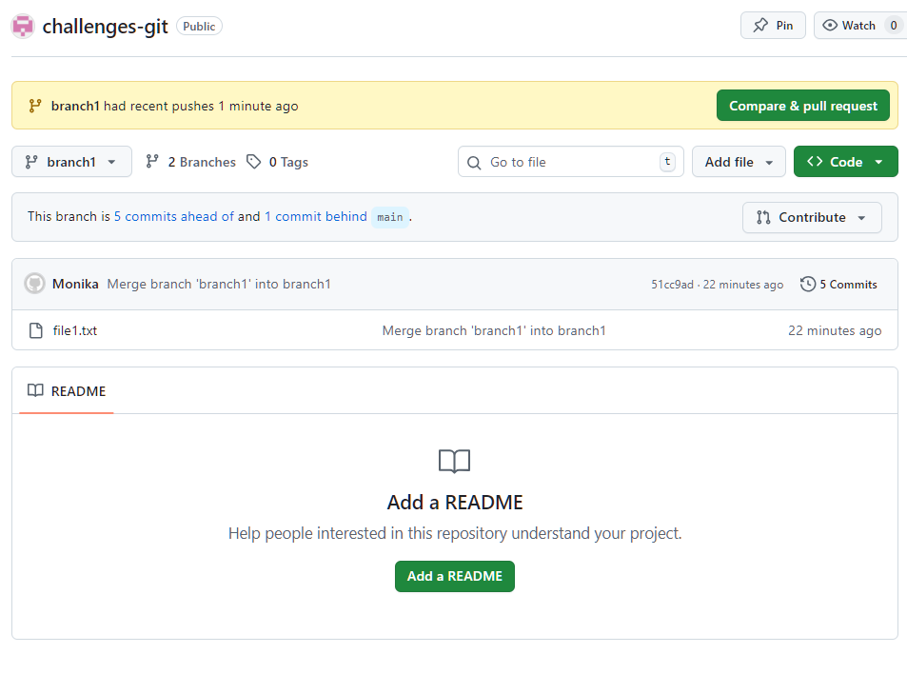

2)Recover Deleted Branch
Delete a local branch and then recover it using the reflog.
• git branch -D branch1 → Forcefully deletes the local branch branch1 even if it is not merged.
• git reflog → Displays a history of all recent Git actions to help recover lost commits or branches.
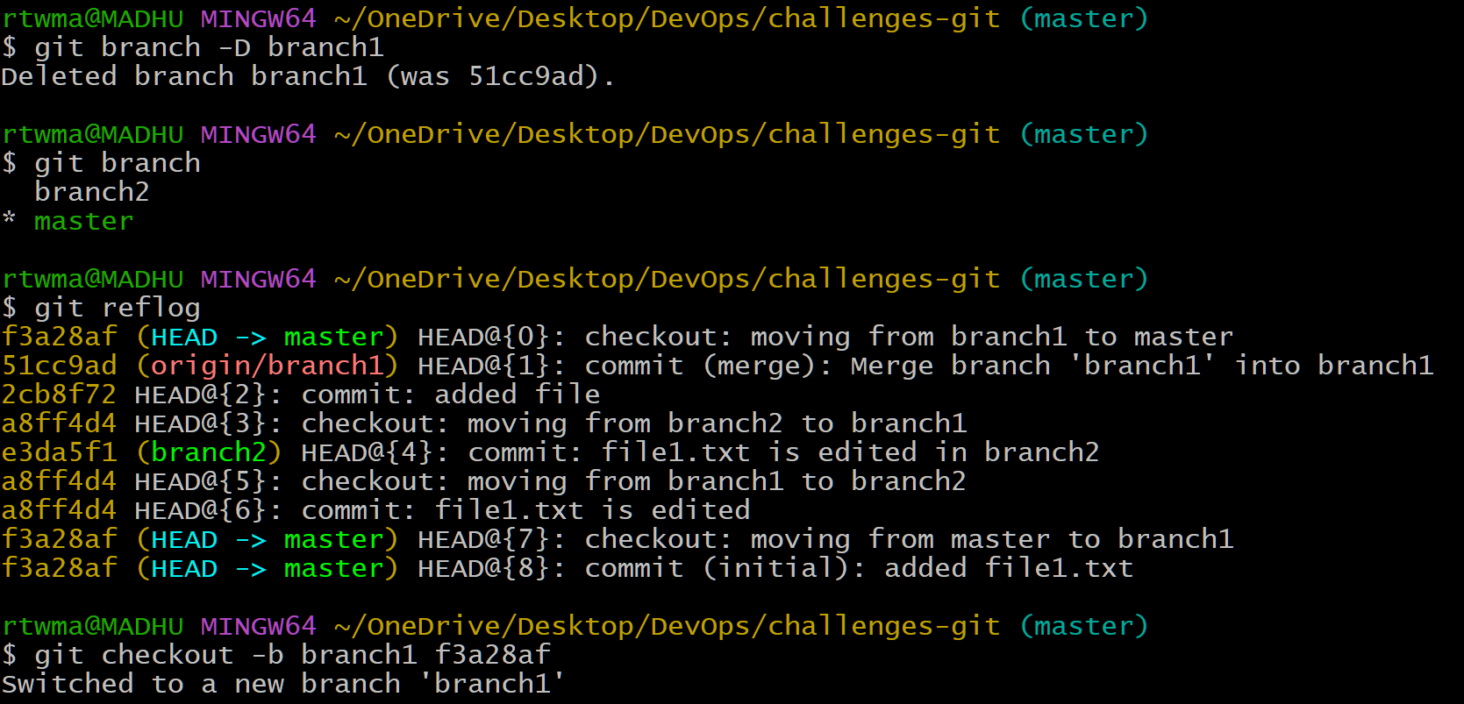
3)Undo Wrong Push
Push a wrong commit to GitHub, then undo it without losing history.
git revert HEAD creates a new commit that reverses the changes made in the most recent commit.
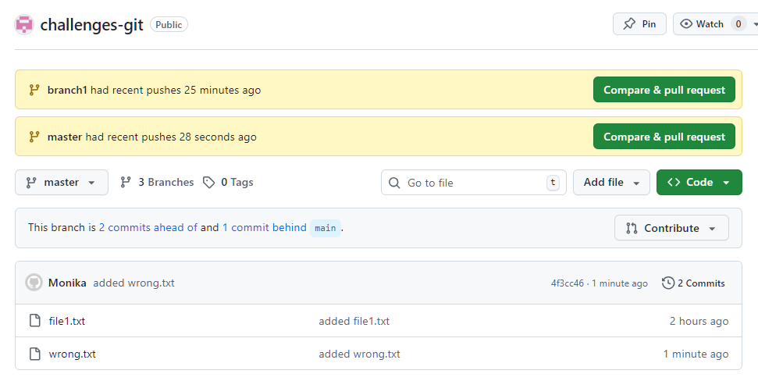
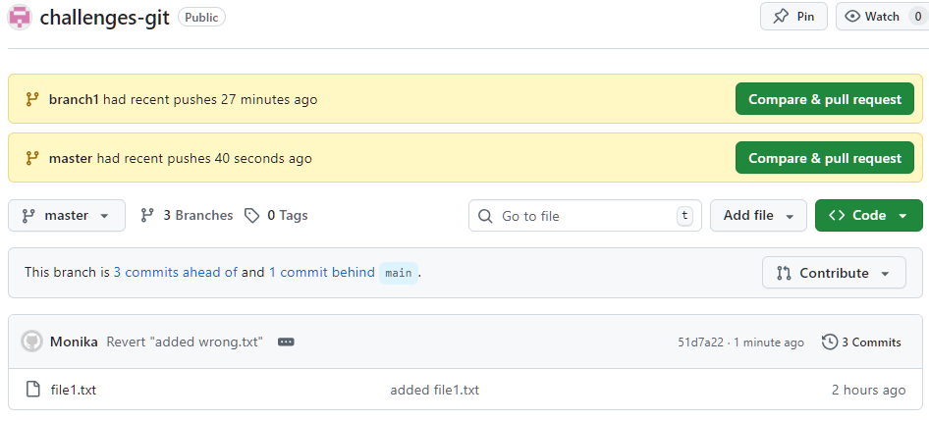

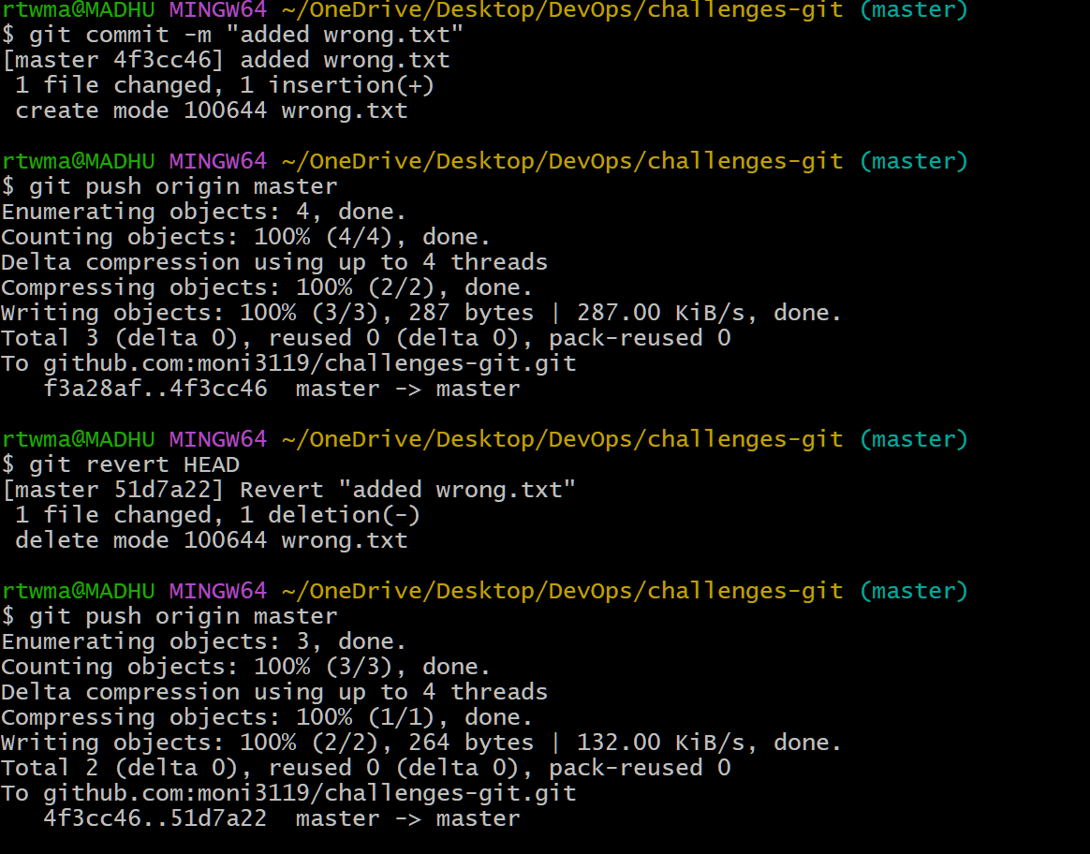

5) Amend a Commit
- Make a commit, then add a missing file to it using git commit --amend.
git commit --amend is used to modify the most recent commit by adding changes or updating its message.
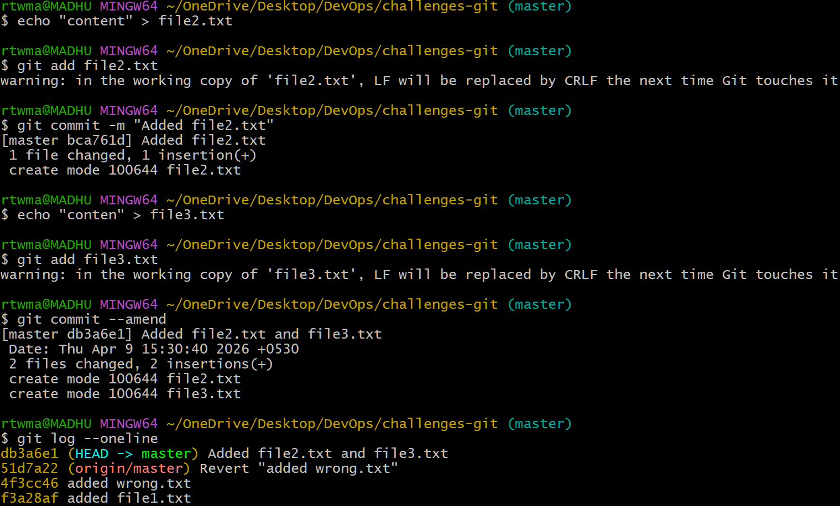
6) Cherry-pick a Commit
Take a specific commit from one branch and apply it to another branch.
git cherry-pick is used to apply a specific commit from one branch onto another branch without merging the entire branch.
-First I have opened the list of logs and took the commit which I want to add.
-I have changed to another branch
-Git cherry-pick <commitid>
-Next checked the logs whether the commit id is added or not.
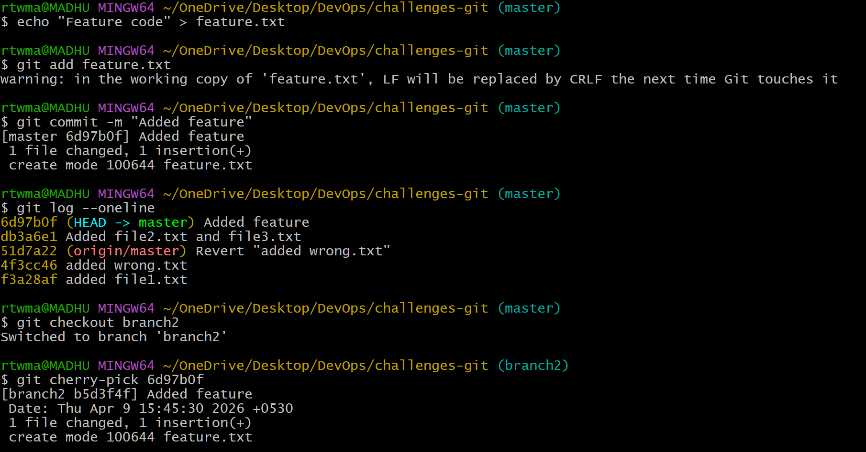
7) Interactive Rebase
Reorder and squash multiple commits into a single clean commit.
git rebase -i HEAD~4 :- Interactive rebase is used to combine multiple small development steps into one clean and meaningful commit.
-I have opened the list of logs and I want to squash below 3 marked commits to a
single commit.

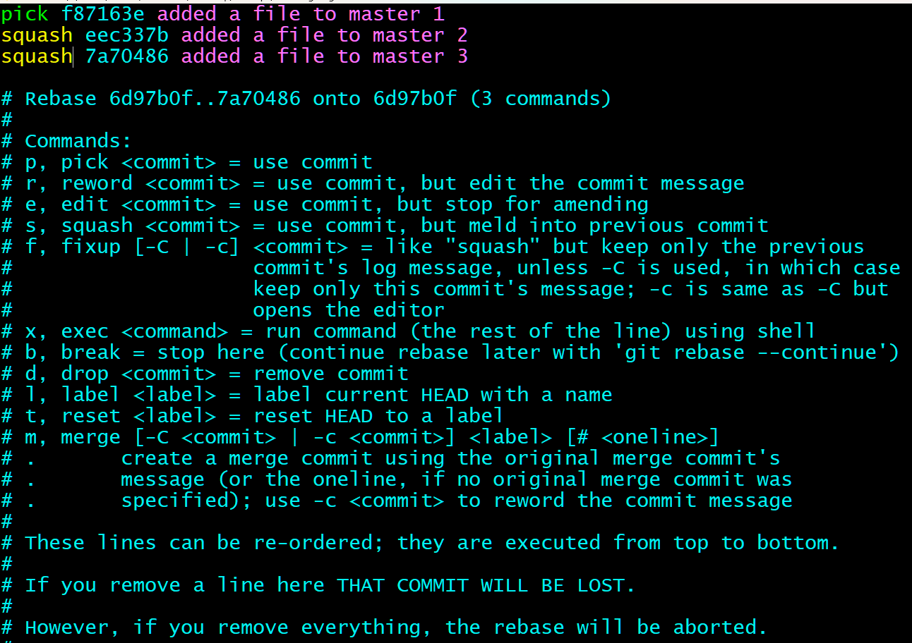
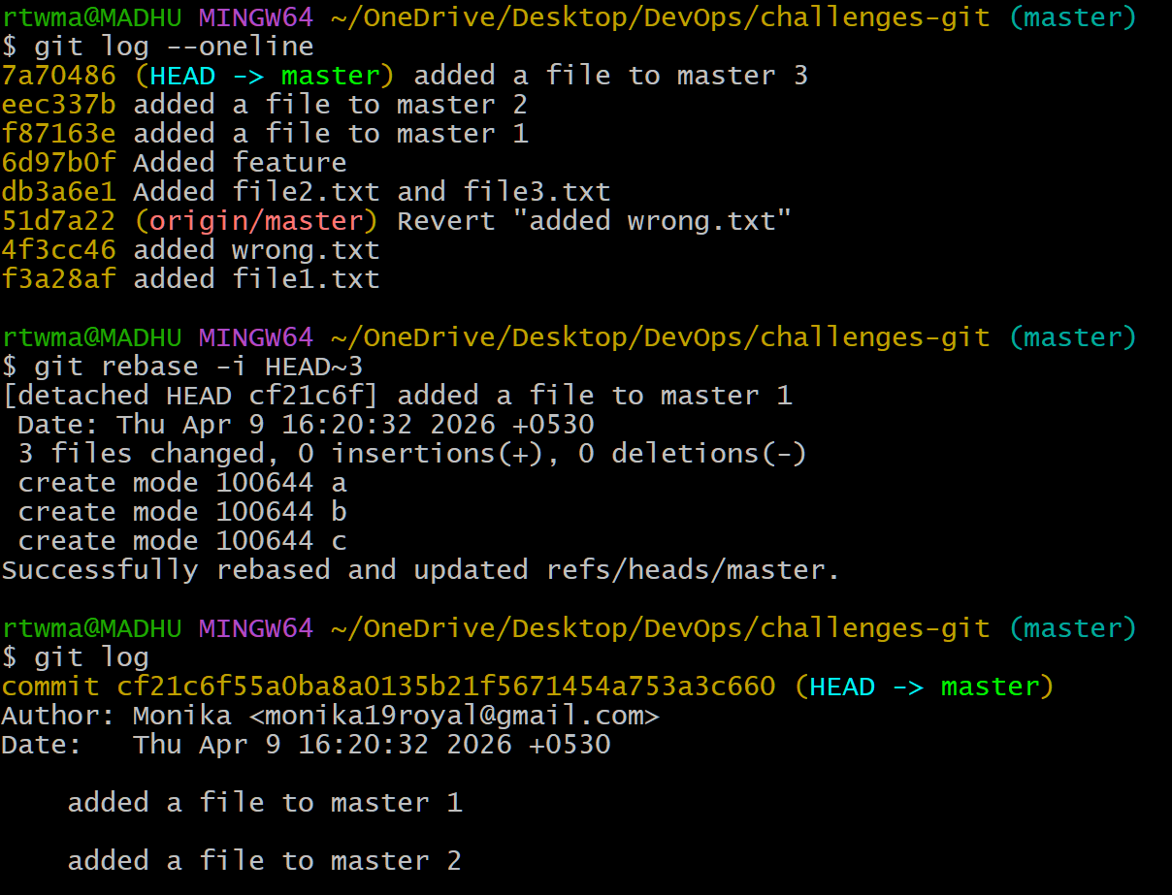
8) Tagging & Release
Create a version tag (v1.0), push it to GitHub, then delete and restore it.
Git tagging is used to mark specific commits as versions or releases and manage them in the repository.
I have created a file name app.txt. I have added and committed it.
- Next I have created a tag
- Pushed it to github
-Verified whether the tag is pushed into github
- I have deleted tag from local and github
- I have picked the commit id and reverted the version back and pushed it to
github

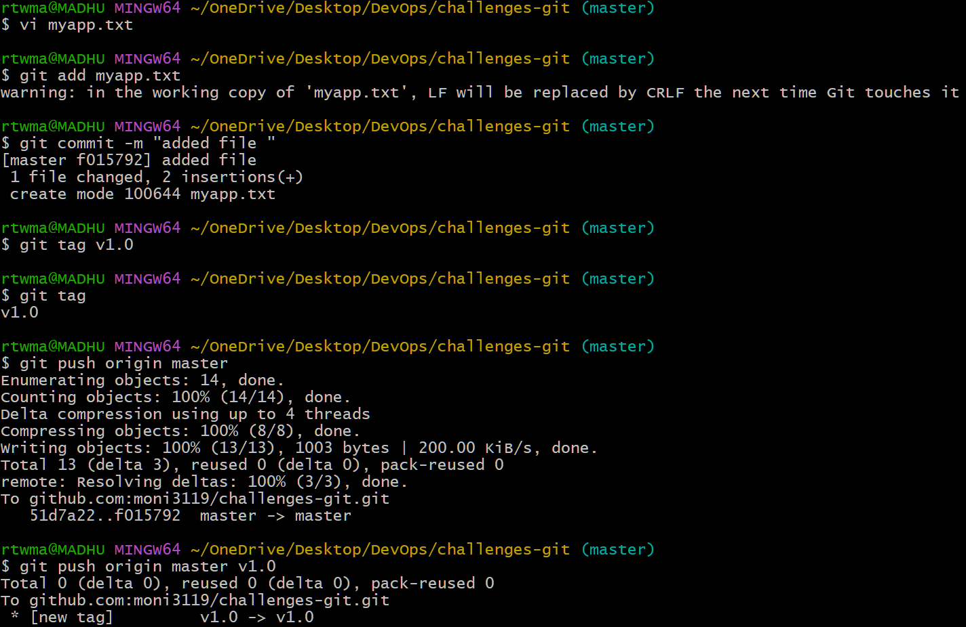
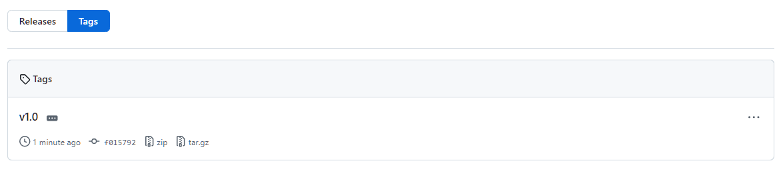
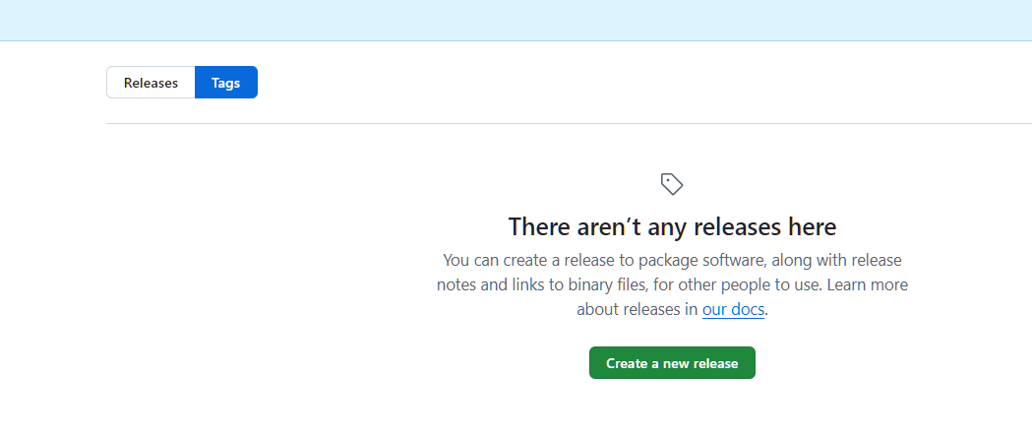
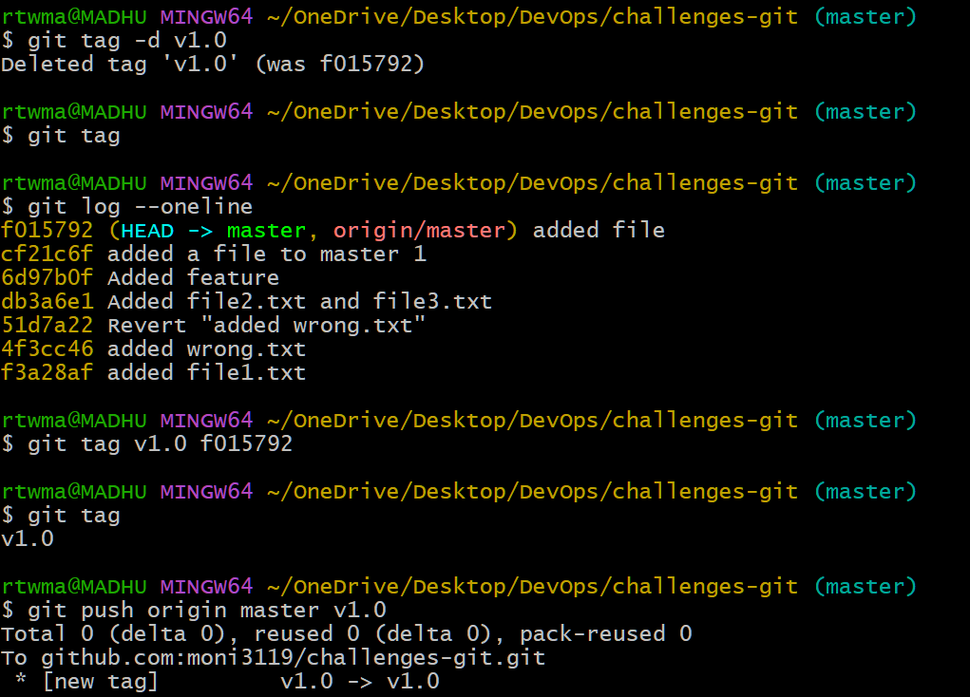
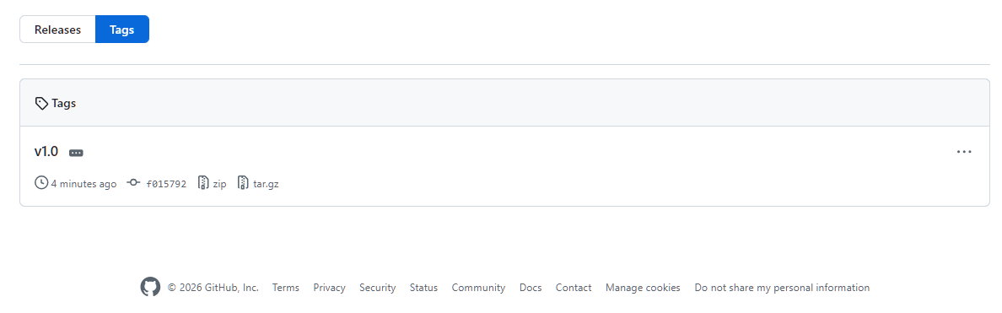
9) Clone with Sparse Checkout
Clone only a subdirectory of a repo using sparse checkout.
10) Reset vs Revert Challenge
Demonstrate the difference between git reset --hard and git revert in a repo.
• git reset --hard → Removes commits and their changes completely from the commit history.
• git revert → Creates a new commit that undoes the changes of a previous commit without deleting history
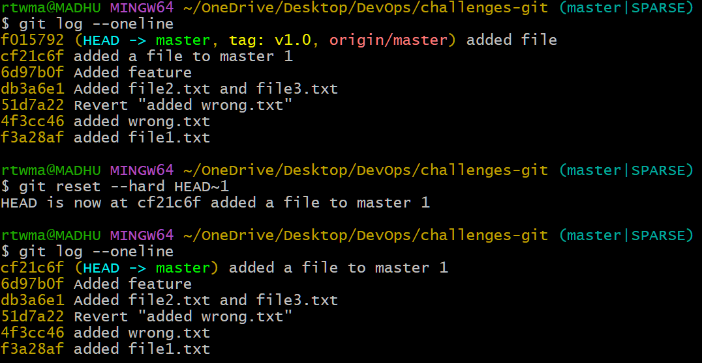
Git revert
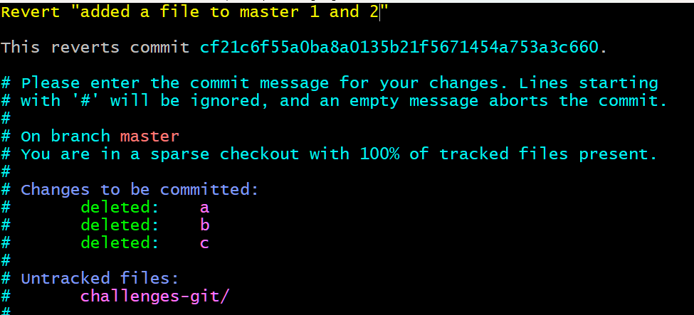
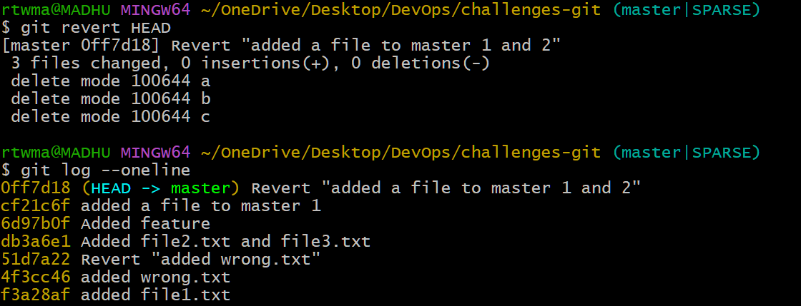

11) Detached HEAD Challenge
Checkout a specific commit (detached HEAD state) and create a new branch from it.
-I have selected a specific commit to detach
-I have made changes in detached state
- It switches to commit
- Created a new branch and verified
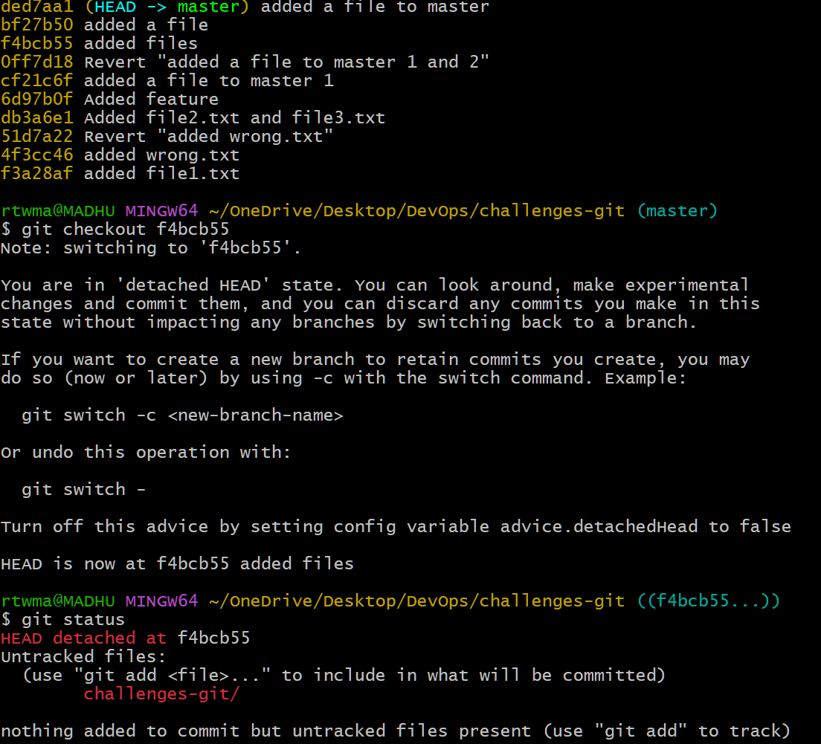

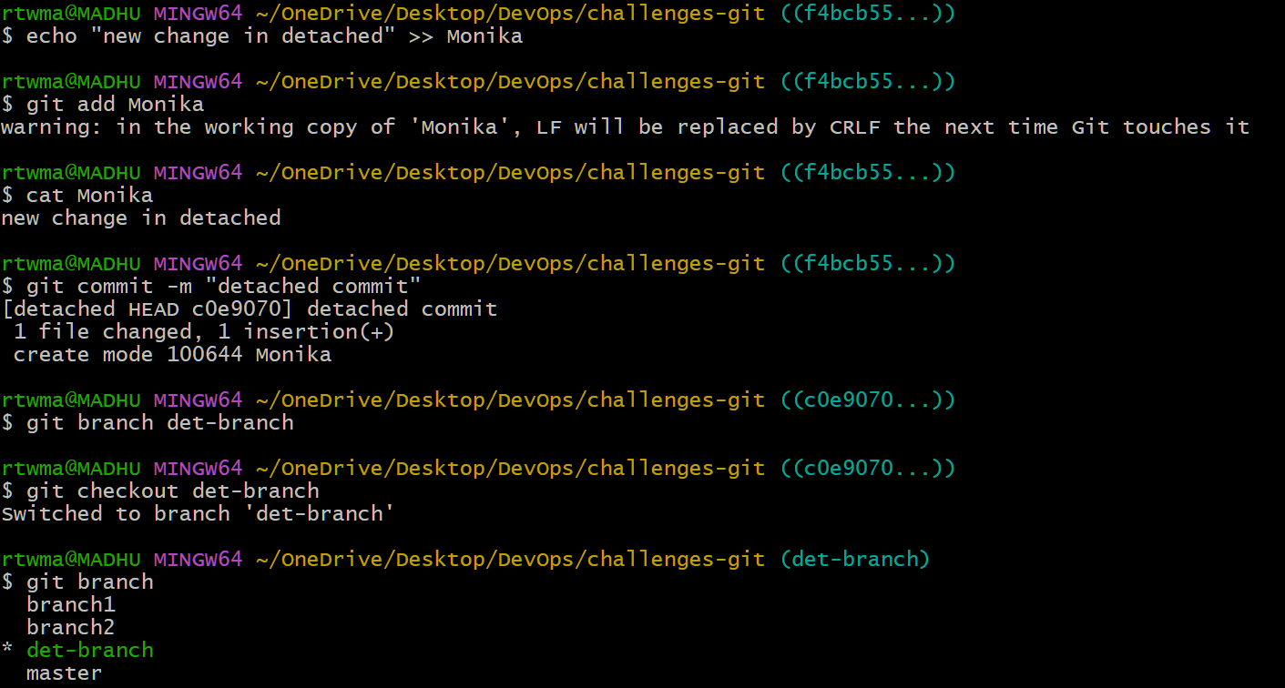
12) Git Hooks Challenge
Configure a pre-commit hook to reject commits without a message format (e.g., must start with JIRA-XXX).
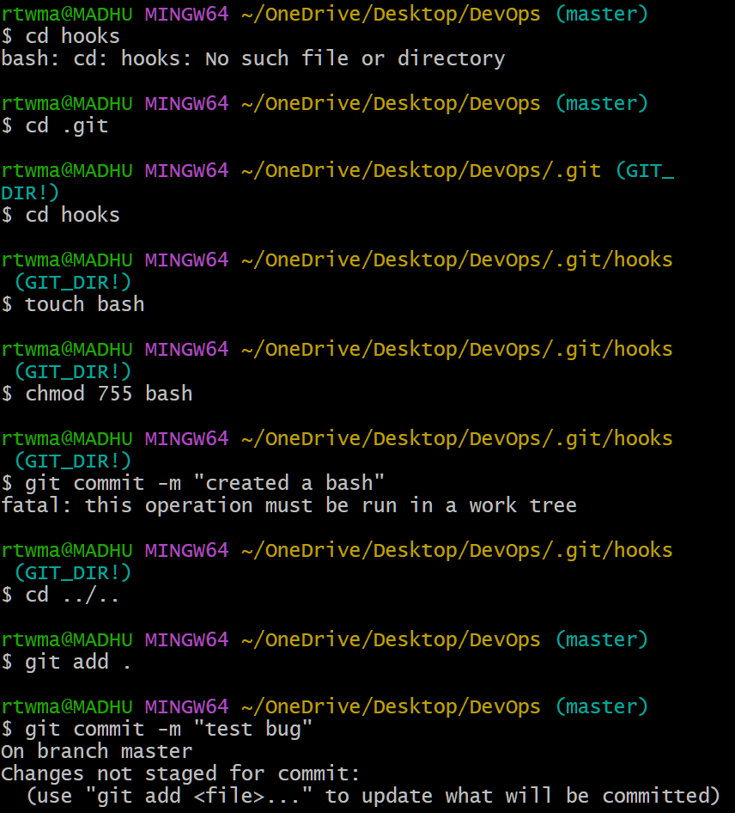

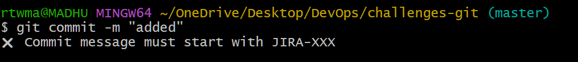

13) Squash Merge vs Rebase Merge
Show the difference between squash merge and rebase merge with evidence.
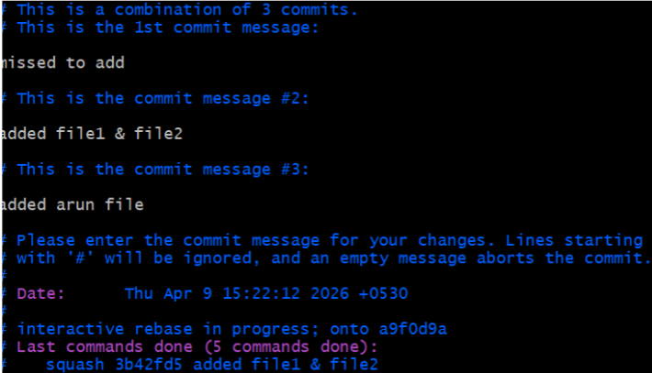
14) Fork & Pull Request Workflow
Fork a repo, make a change, and submit a pull request to the original repo
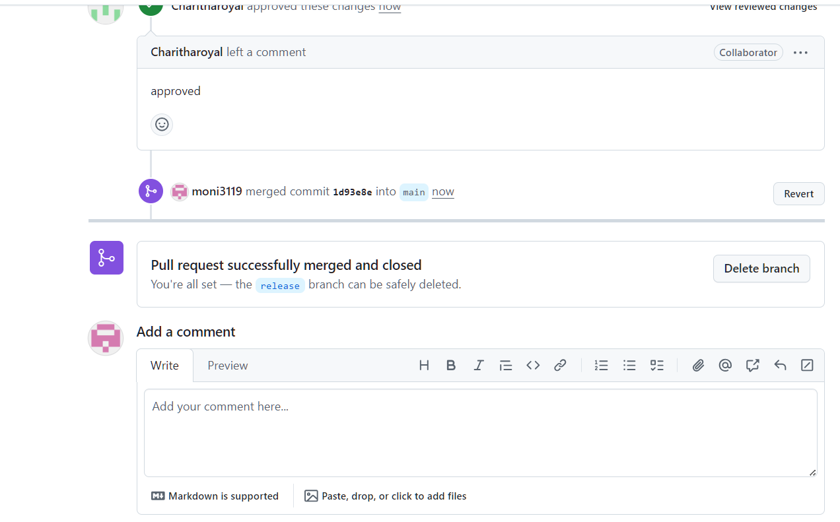
15) Recover Lost Commit
Commit something, reset hard, and then recover it using git reflog
